PATH Intl. and Touchstone Farm ESMHL Required Registration Packet and PATH Intl. Forms

EQUINE SPECIALIST IN MENTAL HEALTH & LEARNING WORKSHOP AND PRACTICAL HORSEMANSHIP SKILLS EXAM

at Touchstone Farm, Temple, NH October 4 -7, 2018

FACULTY

Trish Broersma, Lead ES, Faculty Evaluator
Leslie McCullough, Associate Mental Health Faculty Evaluator

CONTACT INFORMATION

Touchstone Farm, 13 Pony Farm Lane, Temple, NH 03084 www.touchstone-farm.org
Phone: (603) 654-6308 Workshop Contact: Winter Keeler, wkeeler@touchstone-farm.org

ESMHL Workshop Practical Horsemanship Skills Exam

Day 1- Thur. (10/4/17): 8:00 am – 5:00 pm Day 3 Sat. (10/6/17): 5:00 pm - 6:00 pm (skills exam review)

Day 2- Fri. (10/5/17): 8:00 am – 5:00 pm Day 4 Sun. (10/7/17): 8:00 am – until all practical

Day 3- Sat. (10/6/17): 8:00 am – 5:00 pm horsemanship skills exams and candidates’ personal and individual evaluation meetings are concluded. All return flights should be scheduled for the evening.

GENERAL SCHEDULE: A detailed day-by-day schedule will be available on the TSF event’s webpage as the event approaches: http://www.touchstone-farm.org/esmhl-instructor-esmhl-certification/

REGISTRATION AND REQUIRED FORMS TO BE SENT IN TO TOUCHSTONE FARM

To register for the workshop, skills exam, or both, please complete the following packet of forms and return to
Touchstone Farm, 13 Pony Farm Lane, Temple, NH 03084 Attn: ESMHL

All forms MUST be received at Touchstone Farm no later than August 15, 2018 as we then need to send all participant registrations to PATH Intl. immediately afterwards.

• Touchstone Farm Registration, Payment and TSF Release forms
• PATH Intl. ESMHL Profile form
• PATH Intl. ESMHL Application form
• PATH Intl. Authorization for Emergency Medical Treatment form
• PATH Intl. Liability Release form
• PATH Intl. Photo Release form

Payments: For the Workshop and/or Certification exam as well as lodging, can be done easily and securely online. Remember when paying online, you will be using two separate product payment boxes one for lodging and one for the workshop participation payment.

https://www.touchstone-farm.org/product/path-workshops-certifications-esmhl/

OR… a check mailed in with registration forms to the address above.
If paying by check, make check payable to Touchstone Farm.

Mailed to: Touchstone Farm 13 Pony Farm Ln. Temple NH 03084 ATTN: ESMHL

Registration Notes:
- Due to the HIGH demand for this ESMHL Workshop & Certification offering , be advised, the course may fill quickly. Touchstone Farm has created a “participant friendly” online payment process to reserve your spot at this workshop. Sign Up Early!

- The ESMHL Instructor workshop and certification offering at Touchstone Farm is a NON REFUNDABLE program. This is due to the popularity of the program as well as limited availability and instructor travel requirements nationally.

ESMHL Workshop & Horsemanship Skills Exam Registration Form
NOTE: Even if you pay for this event at www.touchstone-farm.org, DOWNLOAD, PRINT, FILL-IN and MAIL page 3-10 to TSF

Name:
Email:
Address: Home Phone: Cell Phone: Do you have any special needs or concerns? Do you have any dietary needs or concerns? i.e veggie only options, or gluten free

Event Registration Expense: All registrations and payments MUST arrive at Touchstone Farm no later than August 15th 2018.

◻ ESMHL Workshop AND Practical Horsemanship Skills Exam $575/per person

◻ ESMHL Workshop ONLY $500/per person

◻ Practical Horsemanship Skills Exam ONLY $125/per person
(MUST have proof of having attended a PATH Intl. ESMHL Workshop within the last 2 years)

◻ Auditing ONLY with manual $175/per person

◻ Auditing ONLY without a manual $115/per person

◻ Overnight Lodging at Stepping Stone Lodge* (per person) $345/Thur – Sat nights
*Includes dinners

◻ Single night Lodging at Stepping Stone Lodge* (per person) $115/Thur – Sat nights
*Includes dinners

◻ Overnight Lodging (Wed ONLY) at Stepping Stone Lodge* (per person) $75/per person
*Does NOT Include dinner

TOTAL Enclosed

Emergency Contact Information

Name: Relationship to participant:
Home Phone: Cell Phone: Other (specify):

Touchstone Farm - Communications & Marketing

How did you hear about our program? Touchstone Farm may use photos taken during this event on our website, Facebook page, and in other communications. If you do NOT want photos of you to be used in this way, check here: 

Participant Signature

Signature: Date:

Payment Type

◻ Check Enclosed: Payable to Touchstone Farm
◻ Credit Card (Visa/Mastercard/Amex/Discover)
Note: A 4% credit card processing fee will be added to all credit card payments.

Number: Exp Date:

Signature: Security Code:

TSF release forms: please read, sign and mail back to TSF, Attn: ESMHL

Touchstone Farm Covenant

, of ,
(Printed Name: Participant) (Physical Address)

for myself and for my heir legal representatives, and assigns, in partial consideration of the acceptance of

for participation in the Touchstone Farm Inc., Pony Farm or Horse
Power (Participant)

Programs and/or associated activities, and being fully and completely aware and knowledgeable of the assumption of risk of personal injury which I seek to make by becoming a member of the Touchstone Farm Inc., Pony Farm or Horse Power Program do, for as long as I remain a member of the Touchstone Farm Inc., Pony Farm or Horse Power Program or use its facilities, equipment and amenities, covenant with the Touchstone Farm Inc., Pony Farm or Horse Power, its heirs, legal representatives and assigns, to never institute any suit or action at law or in equity against the Touchstone Farm Inc., Pony Farm or Horse Power, by reason of any claim which I now have or may hereinafter acquire relating to personal injuries which may be sustained by me/my child arising from participation in the Touchstone Farm Inc., Pony Farm or Horse Power Programs and use of the facilities provided by the “Touchstone Farm Inc., Pony Farm, or Horse Power.”

The undersigned acknowledges that there exist inherent risks of personal injury in the sport of riding and driving or handling of horses and the undersigned agrees to assume such risks and hold the Touchstone Farm Inc., Pony Farm or Horse Power harmless for any injuries incurred by the undersigned and/or their children while riding, driving or handling horses at Touchstone Farm Inc., Pony Farm or Horse Power.

I expressly reserve all legal remedies arising from tortious injuries intentionally or with malice, and expressly reserve any and all rights, causes of action, claims and demands against any person, firm or corporation other than the Touchstone Farm Inc., Pony Farm or Horse Power its owners, heirs, legal representatives, staff and assigns and employees.

Signature Date
(Participant)

Touchstone Farm Liability Release

(Participant’s name) would like to participate in the Pony Farm or Horse Power or Driving Program at Touchstone Farm Inc. I acknowledge the potential risk of horseback riding, vaulting or driving. However, I feel that the possible benefits to my son, my daughter, my ward or myself are greater than the risk assumed. I hereby, intending to be legally bound, for myself, my heirs and assigns, executors or administrators waive and release forever all claims for damages against Touchstone Farm Inc., Pony Farm or Horse Power, its Board of
Directors, Instructors, Therapists, Aides, Volunteers and/or employees for any and all injuries and/or losses I, my son, my
daughter, my ward may sustain while participating in Touchstone Farm Inc., Pony Farm or Horse Power.

Signature: _

(Participant)
Date: _

Touchstone Farm Photo Release

Participant’s Name: _
Date: _

I hereby consent to and authorize the use and reproduction by Touchstone Farm Inc., Pony Farm or Horse Power of any and all photographs and any other audiovisual materials taken of me/my son/my daughter/my ward for promotional printed material, educational activities or for any other use for the benefit of the program.

Signature: _ Date: _
(Participant)

Touchstone Farm Authorization for Emergency Medical Treatment Form

In the event emergency medical aid/treatment is required due to illness or injury during the process of participating in the PATH Intl. ESMHL Workshop and/or ESMHL Practical Horsemanship Skills Exam, or while being on the property of the hosting PATH Intl.
Center, I authorize the PATH Intl. ESMHL Faculty/Evaluators to:

1. Secure and retain medical treatment and transportation if needed.
2. Release participant records upon request to the authorized individual or agency involved in the medical emergency treatment.

Participant’s Name: Address: City/State/Zip:
In the event that I cannot be reached, please contact:
Name: Name:
Phone: Phone:
Relationship: Relationship:

Physician’s Name: Phone:

Preferred Medical Facility:

Health Insurance Company:

Policy #:_

Consent Plan
This authorization includes x-ray, surgery, hospitalization, medication and any procedure deemed “life saving” by the physician. This
provision will only be invoked if the person listed below is unable to be reached.

Consent Signature: Date: (Participant, Parent or Guardian)
Print Name: Phone: Address:

Non-Consent Plan
I do not give my permission for emergency medical treatment/aid in the case of illness or injury during the process of participating in the PATH Intl. ESMHL Workshop and/or ESMHL Practical Horsemanship Skills Exam process or while being on the property of the hosting PATH Intl. Center. In the event emergency treatment/aid is required, I wish the following procedures to take place:

Non-Consent Signature: Date: (Participant, Parent or Guardian)

Print Name: Phone: Address:

PATH Intl. Profile Form - Touchstone Farm will take care of forwarding PATH Intl. forms directly to PATH for you!

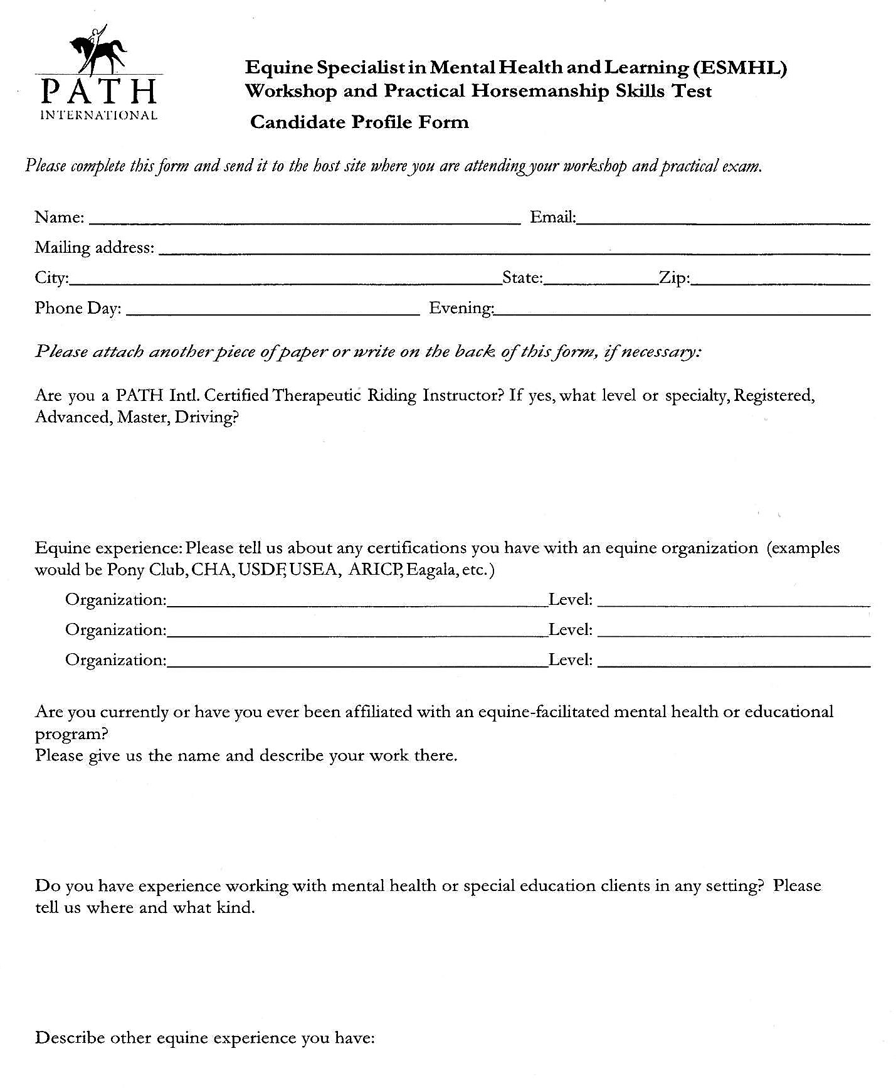

PATH Intl. Application Form

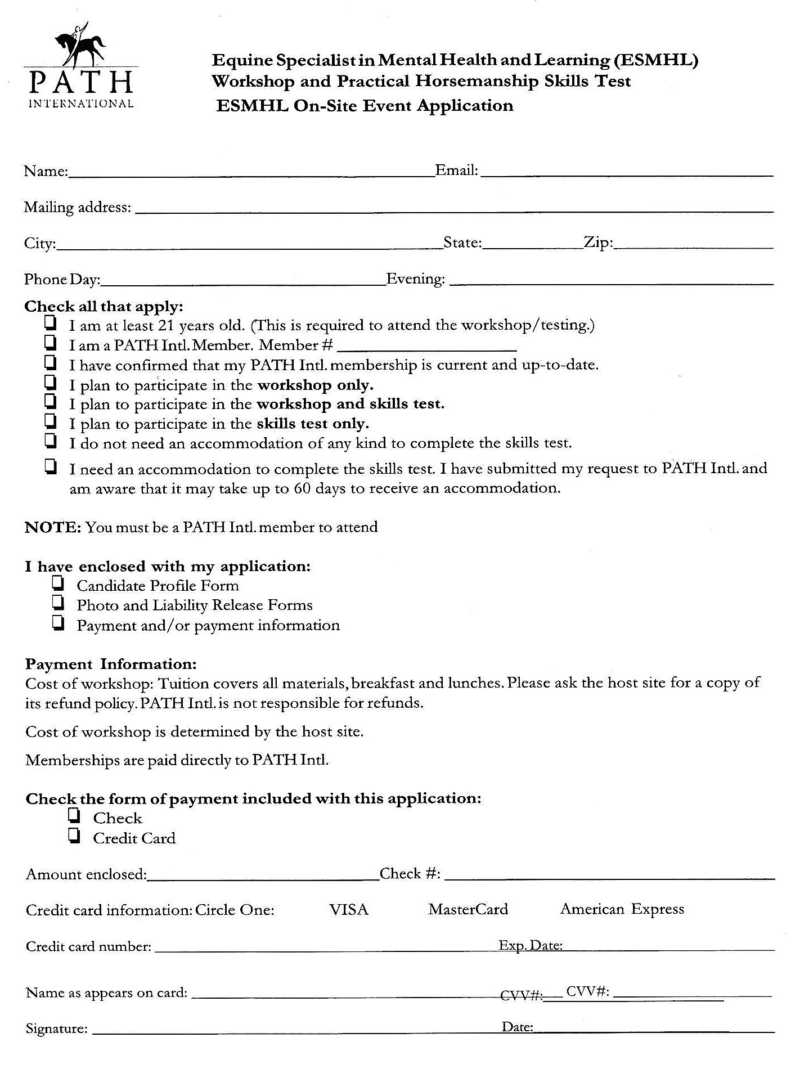

PATH Intl. Liability Release Form

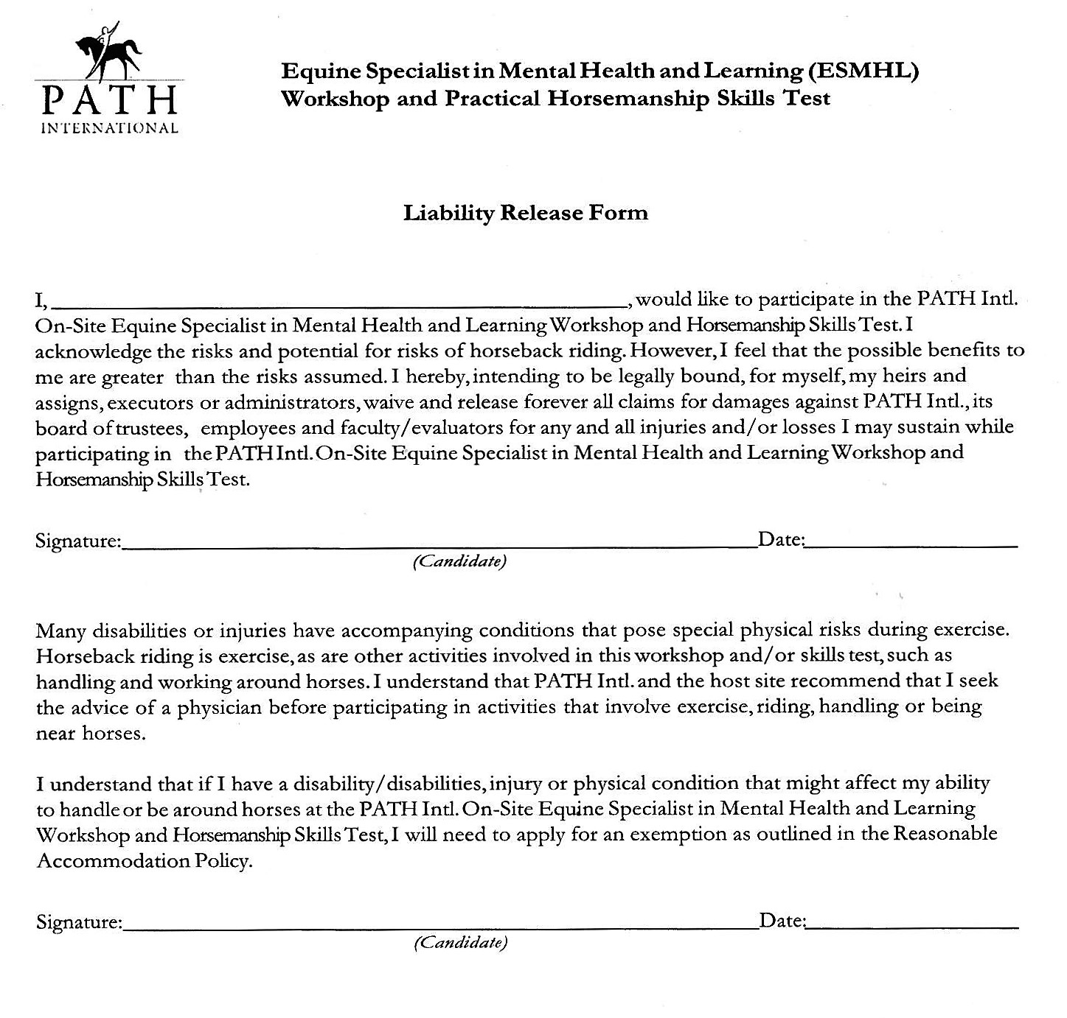

PATH Intl. Photo Release Form

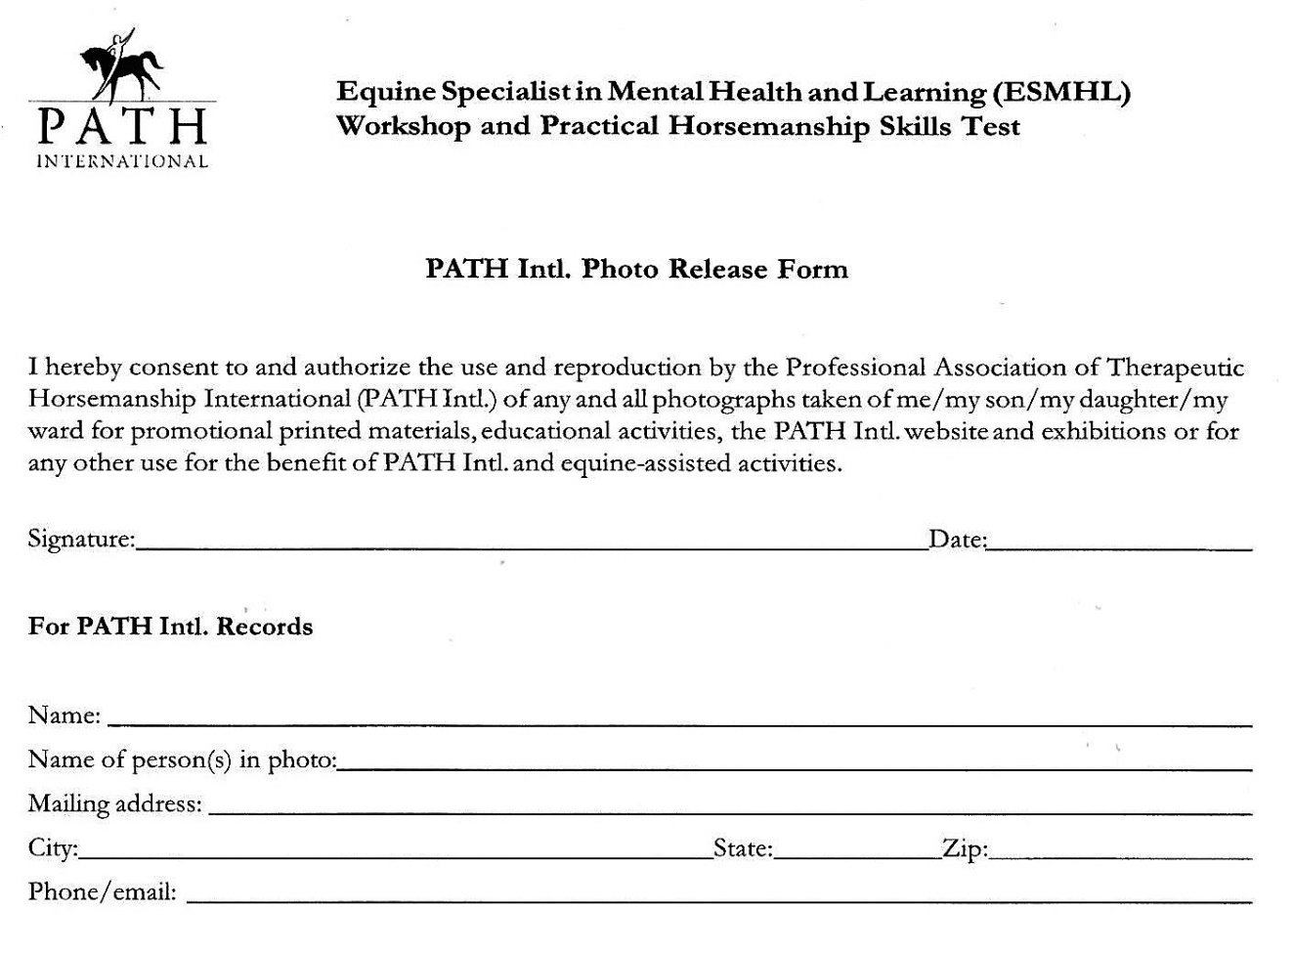

Please don’t forget: pages 3-10 MUST be filled out and returned to:
Touchstone Farm, 13 Pony Farm Lane, Temple NH 03084
Attn: ESMHL
ENSURE your REGISTRATION, register EARLY!

